DATA HARVESTING: USING PERFORM DATA TO FORM QUALITY REPORTS
MSTCVS Surgeons Quality Committee-Approved DQR Project

2024 Perfusion Pay 4 Performance: Leveraging PERForm Data for Quality Improvement
Background: The Michigan Society of Thoracic and Cardiovascular Surgeons Quality Collaborative (MSTCVS-QC) recognizes the importance of using PERForm data to generate quality benchmarked reports to help clinicians make evidence-based practice decisions. Since its inception, the PERForm database has accumulated over 100,000 records for adult cardiac surgical operations utilizing cardiopulmonary bypass. This rich database allows perfusionists and surgeons to review data over time and implement changes in practice to improve patient care and outcomes. The approved 2024 Blue Cross Blue Shield of Michigan Hospital Pay-4-Performance (P4P) project aims to advance the accuracy and reliability of PERForm data. By leveraging analytical tools “PERForm tools” (e.g., Hybrid Analytics, PERForm Metrics Library) provided through our vendor partner, this project will help Chiefs or a Designated Perfusionist use the registry as a powerful tool to drive positive change within their teams. This P4P project will aid in identifying how to use PERForm tools to validate data entries, generate a data quality report and use the data as a representative force to implement collaboration, communication, quality assurance and quality improvement with the entire cardiac team. The goal of this project is to improve the quality of care by each institution by targeting a goal of 100% of cases without missing values for the following PERForm metrics: Intraoperative Insulin Usage, Highest Intraoperative Glucose, Cardiotomy Suction Used and Timing of Cardiotomy Suction Termination. The P4P also seeks to familiarize perfusionists with the PERForm tools (i.e., Hybrid Analytics) as a means to build data tables and create Microsoft Excel graphs to enhance team collaboration by identifying areas of potential improvement and validate areas of success.
Process: The Chief or Designated Perfusionist with access to the Data Quality Report (DQR) will generate and analyze cardiopulmonary bypass cases with surgery dates ranging from January 1, 2024, to September 30, 2024. They will be responsible for ensuring that all submitted records identified in the DQR have complete and accurate data entered for the following fields: Intraoperative Insulin Usage, Highest Intraoperative Glucose, Cardiotomy Suction Used, and Timing for Cardiotomy Suction Termination. Once the DQR is reviewed and 100% validation of data verified, the Chief or Designated Perfusionist with access to the Hybrid Analytics will use the tool to extract data tables of the previously listed metrics encompassing all those patients with dates of surgery ranging from January 1, 2024, to September 30, 2024. Once the data tables and graphs are compiled, a cardiac team meeting will be scheduled. The team will discuss what changes and improvements can be made and brainstorm ideas to improve the quality metric. Each site will need to submit the following 2 collective metrics from the PERForm Metrics Library: 1) Intraoperative Insulin Missing and 2) Intraoperative Glucose >= 180 mg/dL. Each site will need to submit the following 4 metrics from the PERForm Data Tables: 1) Intraoperative Insulin Used 2) Highest Intraoperative Glucose 3) Cardiotomy Suction Used 4) Timing for Cardiotomy Suction Termination. These will all need to be submitted as both Excel sheets and graphs. Each sites Surgeon Champion and Chief Perfusionist will need to sign off on sheet provided stating each metric has been reviewed by both parties.
An example of this process:
- The Chief Perfusionist will use the PERForm Metrics Library to review the metric Intraoperative Insulin Drip Used is Missing and Intraoperative Glucose is greater than or equal to 180mg/dL OR Missing.
- The Chief Perfusionist will review the highest intraoperative glucose values and ensure that the metric was entered correctly and compare how many cases met the glucose threshold of less than 180mg/dL.
- Once all records are completed, the Chief will extract the required data using the Hybrid Analytics tool and convert the data to a Microsoft Excel file to review and develop graphs. The graphs should show the total number of patients collected and how many of those patients had missing values or fallout values with blood glucose at or above 180mg/dL. Another graph would display the number of patients maintaining blood glucose values less than 180mg/dL intraoperatively (defined as O.R. door-to-door).
- Once the data are prepared, a cardiac team meeting will be scheduled. At this meeting, the Chief would present the mined data from PERForm. The team would identify fallout cases and discuss how the patient(s) might have been managed differently.
- The Chief Perfusionist and Surgeon Champion would sign the attached sheet verifying review of data and submit to the MSTCVS QC, along with all the Microsoft Excel data reports and graphs created by the chief.

Documentation: Each PERForm site will need to present a report derived from the PERForm Analytics Tool as both Microsoft Excel worksheets and graphs, and Signature page for Chief Perfusionist and Surgeon Champion.

All documentation will need to be submitted via email by 12 pm (midnight) of November 24, 2024 to dnieter@med.umich.edu at the MSTCVS Quality Collaborative

2024 Value Based Reimbursement Project: PERForm Data Harvesting and Quality Improvement Signature Page
Chief Perfusionist Name: Print | Chief Perfusionist Name: Signature
Surgeon Champion Name: Print | Surgeon Champion Name: Signature

Perfusion
P4P Project: PERForm Data Harvesting and Quality Improvement: Data Report

Attach Data Reports Here

- Percentage of Missingness for Intraoperative Insulin Usage Table, Highest Intraoperative Glucose, Cardiotomy Suction Used, and Timing for Cardiotomy Suction Termination metric (Excel Sheets and Graphs)

- Graph showing Intraoperative Glucose >= 180mg/dL compared to Intraoperative Glucose < 180mg/dL

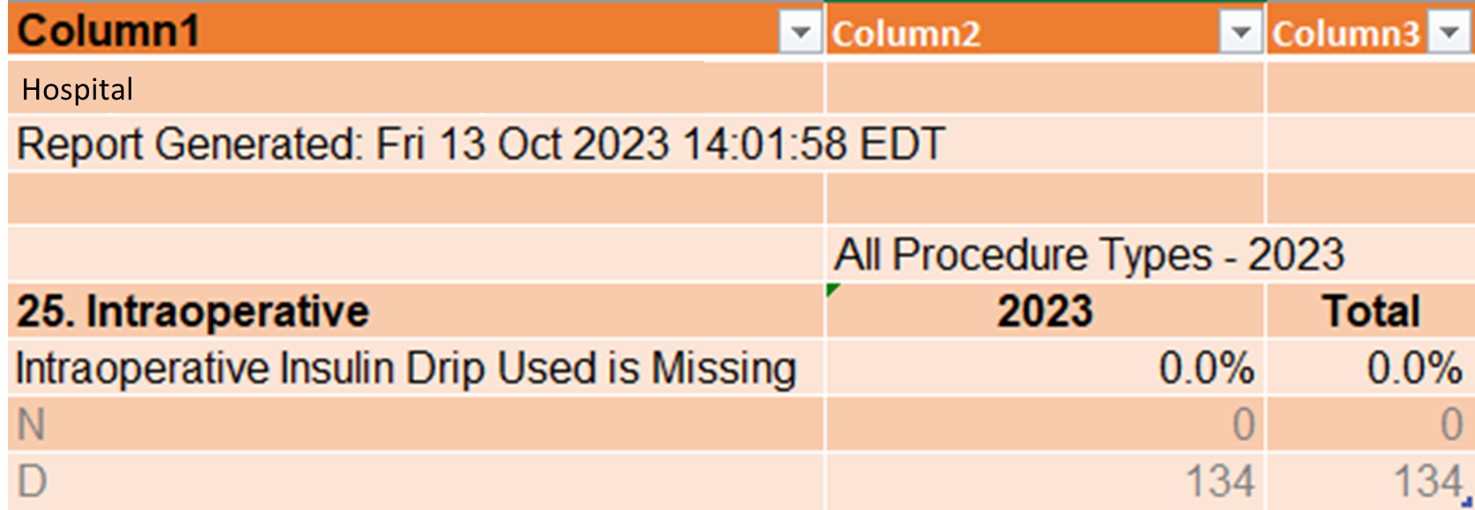

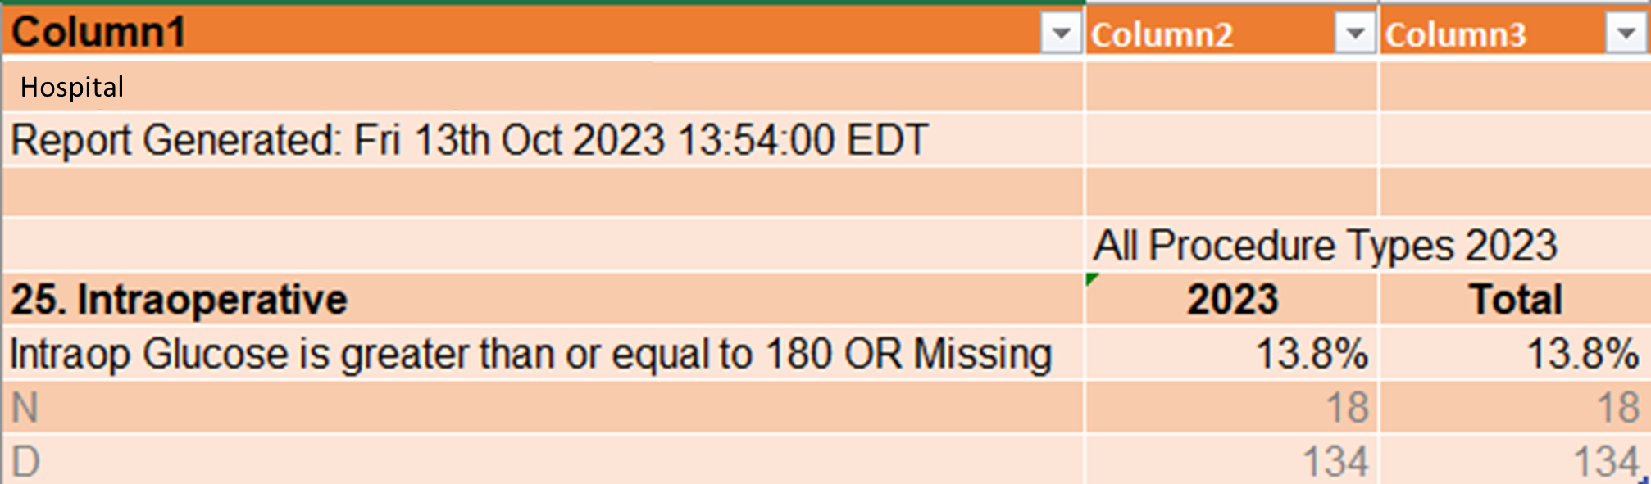

Intraoperative Insulin Drip Used | Highest Intraoperative Glucose
Yes | 156
Yes | 139
Yes | 167
Yes | 159
Yes | 131
Yes | 161
Yes | 144
Yes | 131
Yes | 155

Column1 | Column2
Cardiotomy Suction Y/N | Timing of pump sucker termination
Yes | Prior to, or at initiation of, protamine delivery
Yes | Prior to, or at initiation of, protamine delivery
Yes | Prior to, or at initiation of, protamine delivery
Yes | Prior to, or at initiation of, protamine delivery
Yes | Prior to, or at initiation of, protamine delivery
Yes | Prior to, or at initiation of, protamine delivery
Yes | Prior to, or at initiation of, protamine delivery
Yes | Prior to, or at initiation of, protamine delivery
Yes | Prior to, or at initiation of, protamine delivery
Yes | Prior to, or at initiation of, protamine delivery
Yes | Prior to, or at initiation of, protamine delivery
Yes | Prior to, or at initiation of, protamine delivery
Yes | 1-25% of protamine given

